What Is Our Anti Bullying Strategy?  At Woonona East Public School we support students by  - having clear expectations of student behaviour according to the three core values of respect, responsibility and co-operation;  - providing learning programs that promote resilience, social skills, assertiveness, conflict resolution and communication via the Bounce Back and Being Me programs, Child Protection and Personal Development lessons;  - ensuring vigilant supervision of the playground;  - creating positive classroom environments;  - consistently recognising and rewarding positive behaviour;  - listening to and supporting student voice via the Student Representative Council (SRC);  - maintaining an active Learning Support Team and by  - having an active and supportive P&C Association.  What Are The Consequences of Bullying At Woonona East Public School?  - Detention by the Assistant Principals / Principal when bullying is known to have occurred.  - Parents notified by letter.  - If bullying continues, interview with student and parents by Assistant Principals/Principal and behaviour monitoring card.  - Referral to the school counsellor.  - Loss of involvement in special activities or representation eg sport, excursions.  - Short Suspension up to 4 days.  - Long suspension up to 21 days.  Severe physical violence may lead to immediate short suspension.  For Parents  Could My Child Be Bullying Others?  - Initially you will be defensive and unbelieving. This is natural.  - Find out all the facts, preferably from the school. Telephoning other parents can cause a lot of unnecessary concern.  - Talk to your child but do not blame.  - Emphasise that bullying is not acceptable in your family and provide a positive role model in words and actions.  - Role-play / act out alternative behaviours.  - Seek assistance from the school or health professionals.  - Be specific about consequences for continuing unacceptable behaviour.  - Reward appropriate behaviour.  Is My Child Being Bullied?  Children who are being bullied may not always tell an adult. They may be afraid or embarrassed. The following signs may not necessarily mean your child is a victim of bullying, so you need to discover what is worrying them or making them unhappy.  - Not wanting to go to school, finding excuses to stay home, talking about hating school, not wanting to talk about school at all.  - Bruises, scratches, torn clothing, missing or damaged possessions.  - Being tense, fearful or unhappy after school.  - Changing relationships with siblings, for example, becoming more aggressive towards them.  - Talking about not having any friends.  - Deterioration in school work.  How Can I Help My Child?  - Listen carefully to them.  - Assure them it is not their fault.  - Stay calm.  - Get accurate details |  | Woonona East Public School  ANTI BULLYING POLICY 2010  RESPECT RESPONSIBILTY COOPERATION  Bullying is unfair and one-sided. Recognising bullying and knowing what to do when it occurs are important skills for children to learn. The New South Wales Department of Education and Training rejects bullying and racism in all their forms. Students who are able to build strong friendships and treat others with respect feel safer at school and are less likely to become the victim of bullies. Bullying is a serious matter and is not accepted at Woonona East Public School.  What Is Bullying?  Bullying is repeated behaviour by an individual or group that causes distress, hurt or undue pressure to others. Bullying behaviour can be  Verbal ( name calling, teasing, abuse, humiliation, sarcasm, threats or insults)  Physical (hitting, punching, kicking, scratching, tripping, spitting)  Social (ignoring, excluding, ostracising, alienating or making inappropriate gestures)  Psychological (spreading rumours, glaring, hiding or damaging possessions, malicious SMS or email messages, inappropriate use of camera phones)  Sexual harassment is also a form of bullying.  Bullying is not  - a situation of mutual conflict.  - single episodes of nastiness.  - Give your child some strategies to cope. (For Students – How Can I Handle Bullies?)  - If the bullying doesn’t stop talk to your child’s teacher about what can be done to help.  - If the problem continues, seek assistance from the Assistant Principals and the Principal.  The vast majority of bullying occurs in front of other children. If your child witnesses bullying behaviour emphasise the importance of challenging and/or reporting it.  For Students  How Can I Handle Bullies?  - Avoid them. Walk away. Never find yourself alone with them. Stay in sight of an adult. There is often strength in numbers.  - Be firm and strong even if you don’t feel it. Look them straight in the eye and stand up tall. Say loudly, “That’s bullying. Stop it, I don’t like it.” Then walk away.  - Find a friend. Play with friendly children.  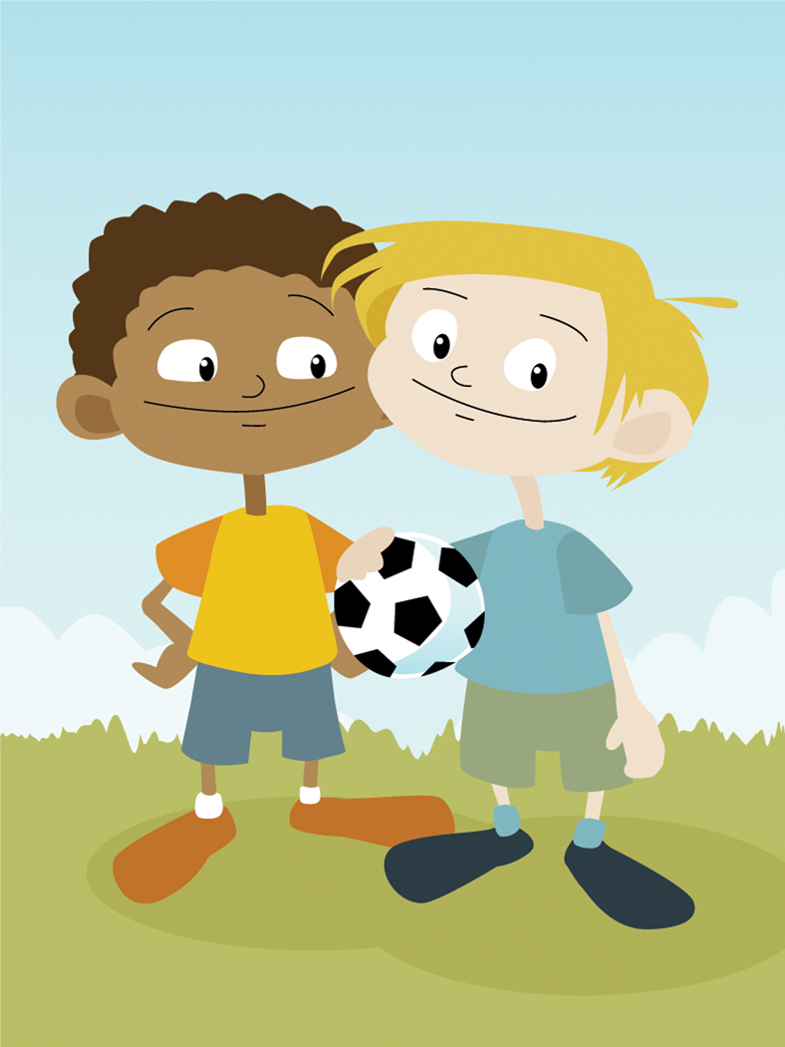  - Tell an older student or older brothers and sisters.  - Don’t fight back physically. It just gets you in trouble too.  - Tell your class teacher, the teacher on duty, the Assistant Principals/Principal.  - If you witness someone else being bullied, stand up for them by challenging it or reporting it to an adult.  - Be careful about teasing people or making personal remarks. If you think that someone might not find your comments funny, don’t say them.

